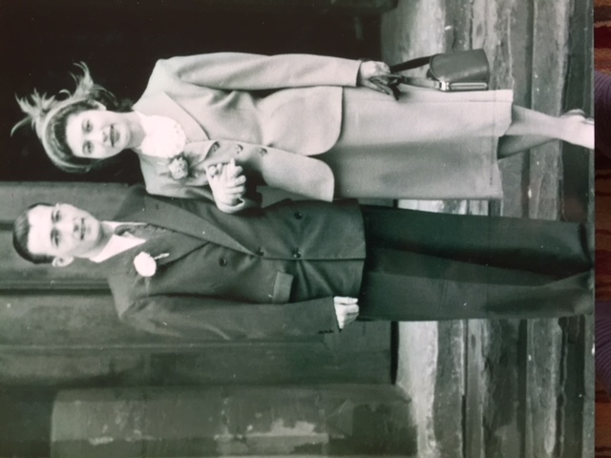

In loving memory of



**Wilf Delooze**

Thursday 26th April 2018

at Walton Lea